1. ℿclass,country (σbore >=16(Classes))

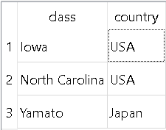

1. ℿname (σlaunched < 1921(Ships))

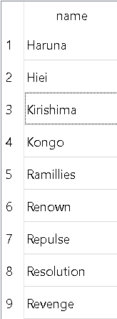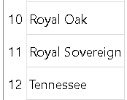

c) ℿship (σbattle = Denmark Strait AND result = sunk(Outcomes))

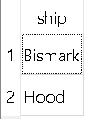

d) R1 = σlaunched > 1921(Ships))

R2 = σdisplacment > 35000(Classes))

R3 = R1 ⨝ R2

ℿname (R3)

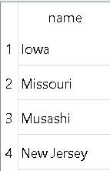

e) Question to ask abbas: when I did this in SQL I got too many rows (23) should re do it or copy all the values?

f)Question to ask abbas: what is a capital ship?

g)R1= ℿclass(σtype = “bb”(Classes))

R2 = ℿclass(σtype = “bc”(Classes))

(R1 ∩ R2)

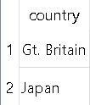

h) Question to ask abbas: do we just look if the ship os damaged or okay???